PERSONAL INFORMATION | Svetla Petrova Ivanova
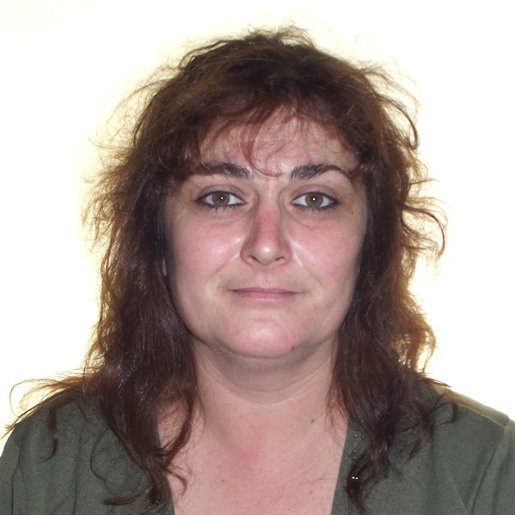 | 
 | 

sara1971@abv.bg
 | Female | 13/06/1971 | Bulgarian

WORK EXPERIENCE

1990-1994  1995-2000  2000-2002  2002-2003  2003-2005  2005-2006  2006-2007  2007-2009  2011-2015 | Clothing Factory(Albena Style, Bulgaria) Seamstress  Assistance/Cleaning Houses/Ironing/Washing(Cyprus)  Cyber Club owner(Dobrich, Bulgaria)  Seller in a shop(Sofia, Bulgaria)  Assistance/Cleaning Houses/Ironing/Washing(Spain)  Kitchen porter/Waitress(Spain)  Packing Dried Fruits(Importaco Ingredients S.L.(Spain)  Kitchen porter(Restaurant La Carmen, Spain)  Part time Assistance/Cleaning/Kitchen porter(Spain)

EDUCATION AND TRAINING

1986-1990  2005 | Diploma for secondary specialized education(Technical)  Packing Course at Importaco Ingredients S.L. | t

PERSONAL SKILLS

Mother tongue(s) | Bulgarian
Other language(s) | UNDERSTANDING |  | SPEAKING |  | WRITING
Other language(s) | Listening | Reading | Spoken interaction | Spoken production
Spanish | C1 | B2 | B2 | B2 | B2
 | Replace with name of language certificate. Enter level if known.
Greek | C2 | C2 | C1 | C1 | B2
 | Replace with name of language certificate. Enter level if known.
Levels: A1/2: Basic user - B1/2: Independent user - C1/2 Proficient user
Common European Framework of Reference for Languages

Computer skills | - Microsoft Office

Driving licence | - B  - M

